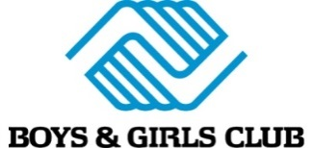

73 W Burd Street

Shippensburg, PA 17257

January 9, 2020

Dear Community Business,

On April 7, 2020, the Boys & Girls Club of Chambersburg and Shippensburg will be having our annual **Steak and Burger Benefit.**

This event will be held at Grant Street Loft, 227 Grant Street, Chambersburg and will include an auction, dinner, raffles, and more

Funds raised through this event will go directly toward the Boys & Girls Club **after school program** and **summer camp** program. These programs serve over 400 children in the Chambersburg and Shippensburg area every day of the week, providing programs that focus on academic success, character and leadership development, and healthy lifestyles. ***The majority of the funding for this organization comes through local businesses, churches, and individuals like you.***

We would like to ask you to consider supporting this event in some way. Maybe it’s by **providing a gift card, gift basket, or an item for our auction** or making a donation towards this event as a sponsor. Anyone who gives to support this event in some way will be recognized on our event program, through a special announcement during the event, and on social media.

Please feel free to check out the event at <https://bgccs.eventsmart.com/?p=84>. If you have any questions, please feel free to contact us. We look forward to partnering with you to make this event a huge success.

Sincerely,

Maggie Lattin

Executive Director

[www.bgccs.org](http://www.bgccs.org)

717-261-5761

[**maggie@bgccs.org**](mailto:maggie@bgccs.org)

----------------------------------------------------------------------------------------------------------------------------------------

**Donation Receipt**

Donation:

Amount:

Authorized Signature: